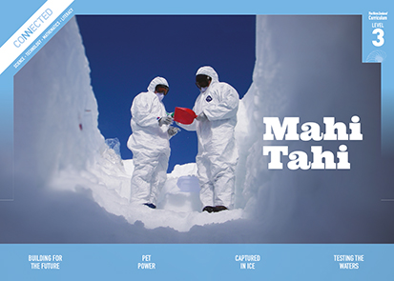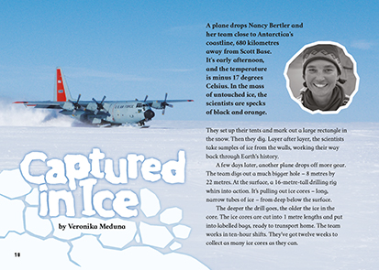
Connected
Level 3
2017

Captured in Ice
by Veronika Meduna

Overview
This article describes how scientists take core samples of Antarctica’s ice to reveal Earth’s history. It shows the importance of learning about the past to understand what may happen in the future, as scientists link rising CO₂ levels to an increase in Earth’s temperature.
A Google Slides version of this article is available at www.connected.tki.org.nz.

Curriculum contexts

SCIENCE: Nature of Science: Participating and contributing  Level 3 – Students will:  - use their growing science knowledge when considering issues of concern to them  - explore various aspects of an issue and make decisions about possible actions. | Key Nature of Science ideas  When we engage scientifically with an issue, we:  - Look for a range of scientific information that relates to the issue  - Check that information we use is from a trustworthy source  - Consider the reliability and validity of the evidence  - Decide if and how to respond to the issue, justifying our decisions based on evidence and/or reliable scientific information  - Monitor the effects of any actions we take.
SCIENCE: Planet Earth and Beyond: Earth systems  Level 3 – Students will appreciate that water, air, rocks and soil, and life forms make up our planet and recognise that these are also Earth’s resources. | Key science ideas  - The water cycle is part of our weather system. Rainfall, wind, and humidity are all involved in the water cycle.  - As the wind travels over physical landforms, it collects a large amount of water vapour that falls as rain or snow that can freeze to ice.  - During a state of change, water undergoes one of the following processes: freezing, melting, boiling, evaporating, or condensing. These are all physical changes.  - Dissolving always results in the formation of a solution, that is, a mixture.
ENGLISH: Reading  Level 3 – Ideas: Students will show a developing understanding of ideas within, across, and beyond texts. | Indicators  - Uses their personal experience and world and literacy knowledge confidently to make meaning from texts.  - Makes meaning of increasingly complex texts by identifying main and subsidiary ideas in them.  - Starts to make connections by thinking about underlying ideas in and between texts.  - Makes and supports inferences from texts with increasing independence.

The New Zealand Curriculum

Science capability: engage with science

Capability overview
This capability requires students to use the other capabilities to engage with science in real-life contexts. It requires students to take an interest in science issues, participate in discussions about science, and at times, take action.  The dimensions of this capability can be demonstrated when students engage in discussions about science issues, including those in the media. If these discussions build on the ideas of others, emphasise logical connections, and draw reasonable conclusions, and if the speakers make the evidence behind their claims explicit, then students have the opportunity to practise playing the “game of science” (Resnick, Michaels, & O’Connor, 2010). | This allows them to deepen their understanding of what science is.  Students also need opportunities to be actively engaged in exploring real-life science issues that are relevant to them and their communities. This could involve building new knowledge with others and taking action to address local or global concerns.

More about the capability

The capability in action
Real-life science issues:  - may involve a mix of scientific issues and forms of social-science inquiry, including values and ethics  - provide opportunities to build awareness of which questions can be investigated and which questions science does not answer  - provide opportunities to see science as tentative, that is, developing over time as evidence is gathered or reinterpreted  - provide experiences of uncertainty where there is no clear explanation or solution  - allow students to gather and interpret data about a local situation or to critique a range of evidence and claims  - may generate a range of student views, responses, and possible actions.  Students  Students should have opportunities to:  - take an interest in a range of scientific issues  - participate in discussions about scientific issues  - use their developing capabilities of gathering and interpreting data, using and critiquing evidence, and interpreting representations to create a viewpoint, response, or action on scientific issues.  Teachers can:  - establish a science classroom culture by:  - taking a personal interest in scientific issues, modelling questions, explicitly critiquing evidence, and seeking further evidence  - maximising everyday opportunities to introduce learning conversations that engage students with science and scientific issues | - helping their students to notice and investigate science in their everyday surroundings, such as ice on a puddle, the health of a local stream or river, or what happens as materials are mixed or heated  - listening to and discussing socio-scientific items in the news  - exploring locally relevant and contentious scientific issues, such as irrigation, intensive farming, or the effects of climate change  - support students to identify scientific aspects of an issue  - provide a range of resources and investigation opportunities pertaining to scientific issues that require students to use a range of science capabilities  - encourage students to seek and critically evaluate a range of scientific evidence, opinions, and actions from a variety of sources about an issue  - manage with sensitivity situations where students and their whānau may hold differing and strongly held opinions about a science-related issue, such as irrigation  - support students to identify and take appropriate actions in response to science-related issues.  It is important that students are empowered to be hopeful and see opportunities for positive action and change when considering local and global issues.

More activities to develop the capability

Meeting the literacy challenges

The main literacy demands of this text require students to retrieve and interpret scientific information from explanation and diagrams about the process of analysing ice cores. The text is supported by infographics, graphs, photos, and informational text boxes, but the students will need to read carefully to identify the key science ideas and to understand how scientists interpreted the information.  The text contains several long, complex sentences, explaining and analysing the scientists’ findings. These require the reader to keep track of information and ideas across paragraphs, often by using adverbial phrases to link important ideas. | The following instructional strategies will support students to understand, respond to, and think critically about the information and ideas in the text.  You may wish to use shared or guided reading, or a mixture of both, depending on your students’ reading expertise and background knowledge.  After reading the text, support students to explore the activities outlined in the following pages.

INSTRUCTIONAL STRATEGIES

Finding the main ideas  Have the students read the title, SCAN the article, and read the text on page 18. ASK QUESTIONS to encourage them to wonder what the scientists are doing there. Encourage them to use the headings, the photos, the graph, and infographic to inform their responses.  What do you think Nancy and her team are doing there? What might be “captured in ice”?  Have the students read and DISCUSS the text under “The great white desert” on page 19.  What do you think about the title of this section? What does it suggest about Antarctica?  What do you notice about the word “glaciologist”? What other words do you think it’s related to?  The job of a scientist is to find answers to important questions, problems, or issues. What sort of questions might a glaciologist ask?  What sort of information might a glaciologist be trying to find? What sort of information would be buried in the ice cores? How would you get to it? How might that information be used to predict the future?  Reflecting on what you’ve read so far, what facts have you learned about Antarctica that help you to make sense of Nancy’s work?  EXPLAIN that the students will find answers to their questions as they read the text. Ask them to RECORD their questions on a simple retrieval chart (see example below), along with their ideas about the answers. As they read, they can record what they found out. Encourage them to add any further questions as they read. | Questions My ideas What I learned  What sort of information might a glaciologist be trying to find?  What are the questions a glaciologist might ask?  What sort of information would be buried in the ice cores?  How would you get to it?  How might that information be used to predict the future?  Have the students read “Frozen in time” (page 19). ASK them to create a simple flow diagram to show how particles of snow get trapped in the ice. Help them to MAKE CONNECTIONS between this text, the illustration next to it, and the title of the article.  How does reading this information help you to make sense of the diagram?  Does the title now make better sense to you?  Before the students read pages 20–21, PROMPT them to activate their prior knowledge about greenhouse gases and add any questions they have to the chart. After reading these pages, have the students sketch simple diagrams to show their understanding that CO₂ is one of a number of greenhouse gases that help keep the Earth at a comfortable temperature. Ask them to keep these diagrams for later.

Meeting the literacy challenges

ASK QUESTIONS to help the students unpack the notion of a “greenhouse gas”.  Why are these gases called “greenhouse gases”?  What would the Earth be like if we didn’t have greenhouse gases?  PROMPT the students to look closely at the graph on page 22.  How does the graph overcome the problem of showing two different scales on the same graph (one for CO₂ and one for temperature)?  What does the graph suggest about the relationship between the amount of CO₂ in the atmosphere and temperature?  Does the graph prompt any other questions for you?  Does the graph support your understanding of the relationship between CO₂ and temperature? Why? Why not?  CHECK the students’ understanding of the relationship between fossil fuels, CO₂, and greenhouse gases by having them go back to their diagrams and add these labels to the picture:  Burning fossil fuels releases carbon dioxide.  When there is too much greenhouse gas, too much heat is retained.  The rising of Earth’s average temperature is called global warming.  ASK QUESTIONS to PROMPT discussion about the text on page 23.  What is a sediment core?  Why might scientists need to look at sediment cores instead of ice cores to find out about CO₂ levels millions of years ago?  What do you imagine it would be like to live in New Zealand 3 to 5 million years ago?  Do you have more questions for your chart?  PROMPT the students to look closely at the map and text on page 24.  What does the map show? What is the difference between an ice sheet and an ice shelf? (If necessary, search for this information online.)  What is an ice age? Can you find the last ice age on the graph on page 22? Can you see when others occurred?  Have there been other periods of global warming? Why might they have occurred? How might they have affected life on Earth?  Why are scientists focusing on the West Antarctic Ice Shelf? How fast is it melting? | DISCUSS Nancy’s message:  Do you agree with Nancy about the importance of learning more about Antarctic ice and what it can tell us about the future?  After the reading, have the students REVIEW their charts and reflect on what they have learned. Use this discussion to plan the next steps for science learning.  Were your questions answered?  Are there things that still puzzle you?  Exploring the scientific vocabulary  PROMPT the students to find out more about the word “glaciologist”.  What is the origin of this word?  What other words is it related to?  What does “ology” mean?  What other words can you make with “ology”? What do they mean?  PROMPT the students to IDENTIFY the terms the author uses for describing the past.  What are some other terms people use for talking about the past? What do they mean?  They could go to Dating the past – key terms for more information.

Reading standard: by the end of year 6
The Literacy Learning Progressions
Effective Literacy Practice: years 5–8

Meeting the literacy challenges

TEACHER SUPPORT
Scientists look  for a range  of scientific information that relates to  the issue.  Students use their growing science knowledge when considering issues of concern to them. | 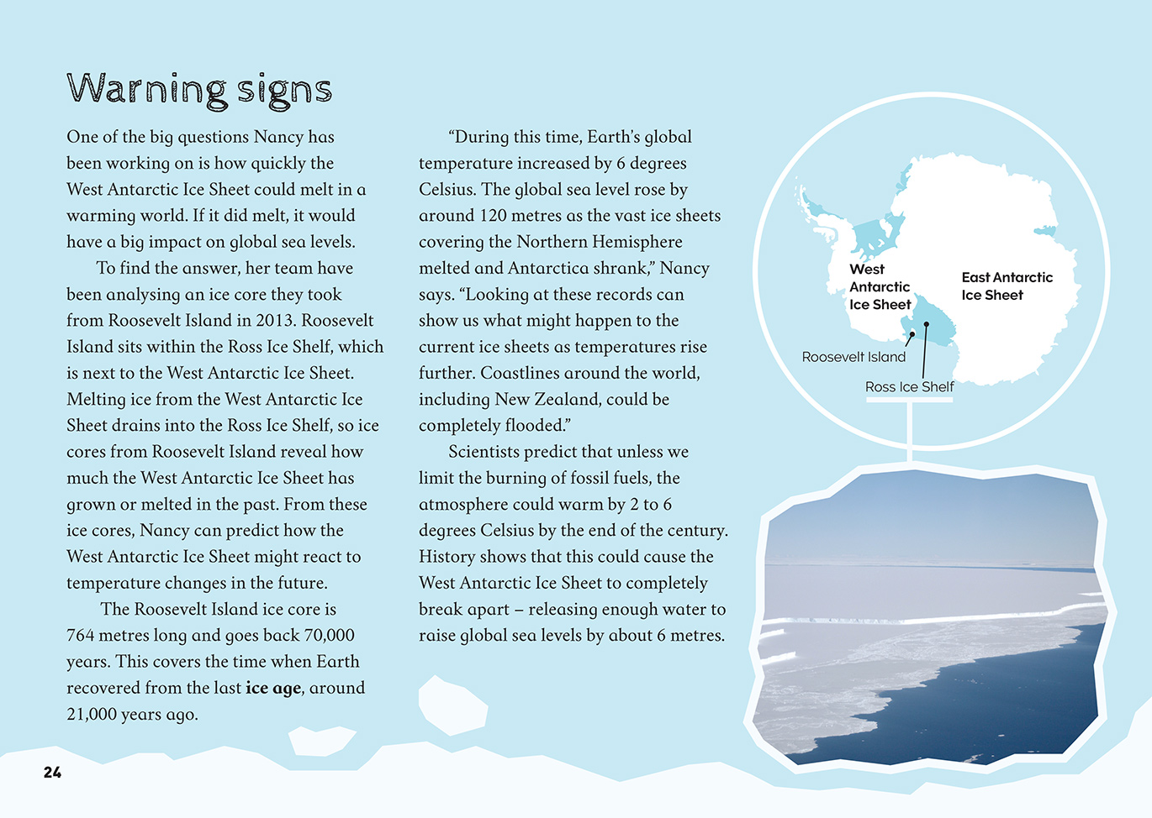  Scientists decide if and how to respond to the issue, justifying decisions based on evidence and/or reliable scientific information.

The above page: Text and images copyright © Crown except: stoat (bottom left) by Nick Goodrum https://goo.gl/5k4VpX, which is used under a Creative Commons licence (CC BY 2.0), A24 trap (bottom middle) which is copyright © Goodnature, and beech forest (bottom right) from https://goo.gl/1kZqA3, which is in the public domain.
The above page: Text and images copyright © Crown except: stoat (bottom left) by Nick Goodrum https://goo.gl/5k4VpX, which is used under a Creative Commons licence (CC BY 2.0), A24 trap (bottom middle) which is copyright © Goodnature, and beech forest (bottom right) from https://goo.gl/1kZqA3, which is in the public domain.
The above page: Text and images copyright © Crown except: stoat (bottom left) by Nick Goodrum https://goo.gl/5k4VpX, which is used under a Creative Commons licence (CC BY 2.0), A24 trap (bottom middle) which is copyright © Goodnature, and beech forest (bottom right) from https://goo.gl/1kZqA3, which is in the public domain.

Learning activities – Exploring the science
The following activities and suggestions are designed as a guide for supporting students to explore and develop understandings about the science capability “engage with science”. Some activities focus directly on the science capability. Other activities extend student content knowledge across the learning areas. Adapt these activities to support your students’ learning needs.

Activity 1 – Preparing for sea level rise

Finding out more
The author reports that if the West Antarctic Ice Sheet breaks apart, global sea levels could rise by about 6 metres. Check students’ understanding of what is meant by the ice sheet “breaking apart” and how this could increase sea levels. To get a sense of what this means, have the students use a tape measure to measure the height or width of a common object. For example, the height of a table, bookcase or shelf; the width of a desk or table top.
What does 1 metre look like? What do 2 metres look like? 4?
What about 6 metres? How high would that be? Let’s go outside to see.
Have the students examine the regional land elevation maps from the Parliamentary Commissioner for the Environment’s report on sea level rise. Ask them to use the maps to identify how sea level rise may affect a place nearby or a place that is well known to the students.
Which places might be at risk if sea level rises half a metre, 1 metre, 2 metres, or more? In New Zealand? In other places around the Pacific?
How might this kind of rise affect the communities in these places? Do you know of places where the effects are already being felt?
Taking action
Discuss what people can do to take action on climate change.
What steps could residents, councils, and governments be taking to prepare for sea level rise?
What steps are being taken?
What steps could we be taking to help reduce the amount of possible sea level rise?
Record the students’ ideas, then ask them to work in groups to identify an action that could help. They can then present their findings to the class. Based on this shared knowledge building, the class could choose and action and promote it to the school community or the wider community.
Extending the learning
The students could focus on the role of scientists in preparing for sea level rise.
What other research is taking place?
How can it help us prepare for the future?
What else would it be useful to know to help us prepare for sea level rise?

Activity 2 – Antarctica and climate change
Select items in the resource links to share with the students to find out more about the work scientists are doing in Antarctica.
What else are scientists learning about the risks of climate change and global warming?
How trustworthy are their findings? How would you critique this?
How could we share this information with other people?
Have the students make a model of Antarctica that shows the ice sheets and shelves. Have them use their model to explain what scientists have learned about what could happen if we continue to discharge CO₂ into the atmosphere at current rates.

Activity 3 – Fossil fuels and their alternatives
Finding out more
Go back to the diagrams the students created and discuss the relationship between CO₂, fossil fuels, and global warming.
Why have the CO₂ levels risen over the past 150 years? What do fossil fuels have to do with it?
Why are we picking on fossil fuels? Are they the only source of CO₂? Is CO₂ the only greenhouse gas?
Have the students research ways New Zealand can reduce its use of fossil fuels.
What could we be doing now to help keep global warming to manageable levels?
What are some alternative fuel sources? What are the pros and cons of the alternatives?
How might reducing our use of fossil fuels affect how we live?
Taking action
Discuss what the students could do to take action to reduce the impact of fossil fuels. Bear in mind that sometimes the discussion can seem quite hopeless. If students express doubts about the value of taking action, encourage them to express themselves and promote respectful debate.
What could we do as a class to help reduce the use of fossil fuels?
Are there things we could ourselves?
Are there other people we could influence?
Is it worth doing anything? What is the possible impact?
What would happen if no one took action?
What would happen if everyone took action?
Record the students’ ideas, then ask them to work in groups to identify an action they could take to reduce our consumption of fossil fuels. Have them find out more about that action and present their findings to the class. You could support this activity with the Connected articles “Lighting the Way with Solar Energy” (Connected 2014, level 4) and “Driving Us into the Future” (Connected 2016, level 4). The resource links for the teacher support materials could help the students in their research.
After the students have shared their ideas, they could choose to implement at least one of the suggested actions. In coming to this agreement, it is likely that the original idea will change. This is an opportunity to reinforce the concept that ideas and activities typically evolve over time as people debate what they have learned from research.

Learning activities – Exploring the science

Extending the learning  There are people who still contest the notion of human-induced global warming. Have the students read “Rising Seas” (Connected 2014, level 3) to learn more about what is happening. Conduct the activity “Is climate change real?” to explore alternative viewpoints.  Activity 4 – Learning from the past to plan for the future  Have the students read “The Tsunami That Washed Time Away” (Connected 2014, level 3) and “The Big Chill and the Big Drill” (Connected 1 + 2, 2008) to learn more about how scientists collect core samples of ice and sediment to “look at the past to predict the future”.  Invite an expert from ESR (Environmental Science and Research) or GNS Science to come to school and show the students how to take and analyse a core sample. The students should have questions prepared beforehand. If this is not possible, the resource links includes videos that the students could watch.  What do you see when taking a core sample?  What are some of the challenges of taking a core sample? | Share this Climate database 2.0 article to find out about the massive database that is being put together to build models of climate change.  What other source of data are mentioned in the article? How is it collected and analysed?  The students could use what they have learned to write, draw, or record descriptions of how scientists collect and analyse samples (such as soil, ice, coral, or tree rings).  Many Māori myths and legends about our physical environment also contain the history of our land. For example, when GNS worked alongside Taranaki iwi, iwi stories about the age of their ancestral maunga were similar to carbon dating by GNS. Learn more about this from the GNS site. Ask the students to find other examples.

RESOURCE LINKS

Connected  “The Big Chill and the Big Drill”, Connected 1 + 2, 2008  “Rising Seas”, Connected 2014, level 3, Why Is That? http://instructionalseries.tki.org.nz/Instructional-Series/Connected/Connected-2014-level-3-Why-Is-That/Rising-Seas  “The Tsunami That Washed Time Away”. Connected 2014, level 3, Why Is That? http://instructionalseries.tki.org.nz/Instructional-Series/Connected/Connected-2014-level-3-Why-Is-That/The-Tsunami-That-Washed-Time-Away  “An Ecologist on Ice”, Connected 2013, level 4, Are You Sure? http://instructionalseries.tki.org.nz/Instructional-Series/Connected/Connected-2013-level-4-Are-You-Sure/An-Ecologist-on-Ice  “Lighting the Way with Solar Energy” Connected 2014, level 4, Is That So? http://instructionalseries.tki.org.nz/Instructional-Series/Connected/Connected-2015-level-4-Is-That-So/Lighting-the-Way-with-Solar-Energy  “Driving us into the future”, Connected 2016, level 4, Getting the Message http://instructionalseries.tki.org.nz/Instructional-Series/Connected/Connected-2016-Level-4-Getting-the-Message/Driving-Us-into-the-Future | Science Learning Hub  Antarctica and global climate change: www.sciencelearn.org.nz/resources/421-antarctica-and-global-climate-change  Climate change, melting ice, and sea level rise: www.sciencelearn.org.nz/resources/2277-climate-change-melting-ice-and-sea-level-rise  Collecting data in Antarctica: www.sciencelearn.org.nz/resources/321-collecting-data-in-antarctica  Investigating sea level rise (activity): www.sciencelearn.org.nz/resources/2278-investigating-sea-level-rise  Dating the past – key terms: www.sciencelearn.org.nz/resources/1552-dating-the-past-key-terms  Satellites measure sea ice thickness: www.sciencelearn.org.nz/resources/261-satellites-measure-sea-ice-thickness  The greenhouse effect: www.sciencelearn.org.nz/resources/1004-greenhouse-effect  Greenhouse simulation (activity): www.sciencelearn.org.nz/resources/1589-greenhouse-simulation  Climate action: www.sciencelearn.org.nz/resources/2215-climate-action

Learning activities – Exploring the science

RESOURCE LINKS continued

Alternative conceptions about fossil fuels: www.sciencelearn.org.nz/resources/1585-alternative-conceptions-about-fossil-fuels  Clues to the past: www.sciencelearn.org.nz/resources/2230-clues-to-the-past  Trapped in ice: www.sciencelearn.org.nz/resources/948-trapped-in-ice  Thin ice in the classroom resource (A series of video clips and support info, including teacher guides, about climate change): www.sciencelearn.org.nz/resources/2233-thin-ice-in-the-classroom  GNS Science  About ice cores – FAQs: www.gns.cri.nz/Home/Learning/Science-Topics/Ice-Snow/About-Ice-Cores  Antarctic ice core drilling (video): www.youtube.com/watch?v=kdfcNIFEnF8  Māori relationships: https://www.gns.cri.nz/Home/About-Us/Maori-Relationships  Antarctica New Zealand  Our scientists: www.antarcticanz.govt.nz/science/our-science/our-scientists/  Classroom Antarctica: www.antarcticanz.govt.nz/education/classroom-antarctica/  LEARNZ  Antarctica – cool science in action (2017): http://rata.learnz.org.nz/summary.php?vft=antarctica174  Antarctica – cool science in action (2016): www.learnz.org.nz/antarctica164  Science on ice (2008): http://rata.learnz.org.nz/summary.php?vft=scienceonice84  Andrill (2008): http://rata.learnz.org.nz/summary.php?vft=andrill74 | Victoria University of Wellington:  Antarctic Research Centre: www.victoria.ac.nz/antarctic  Ice cores: www.victoria.ac.nz/antarctic/research/ice-cores  National Ice Core Laboratory: About Ice Cores  Drilling ice cores: https://icecores.org/icecores/drilling.shtml  Video gallery: https://icecores.org/icecores/videos.shtml  Other sources  Antarctic Glaciers: Ice core basics: www.antarcticglaciers.org/glaciers-and-climate/ice-cores/ice-core-basics/  The Guardian – How do ice cores allow researchers to see climate change? (article and video): www.theguardian.com/science/punctuated-equilibrium/2011/may/12/1  NZ Herald – Q&A: Antarctica – our big icy threat: www.nzherald.co.nz/nz/news/article.cfm?c_id=1&objectid=11472481  Thin Ice – Antarctica and the Ice Core Story: http://thiniceclimate.org/antarctica-and-the-ice-core-story  Parliamentary Commissioner for the Environment – Regional land elevation maps: www.pce.parliament.nz/publications/regional-land-elevation-maps  Scimex – Climate Database 2.0: www.scimex.org/newsfeed/climate-database-2.0  Allianz – Antarctica’s Ice Cores (video): www.youtube.com/watch?v=XpAqepThUNI

